General information about phishing:
1) Phishing was the most reported scam in 2024
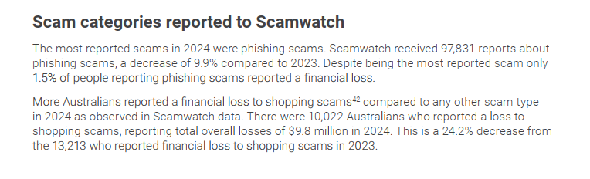
2) Financial Impact: Total combined losses to phishing in 2024 were $84.5 million (This number has been decreased compared to the previous year)
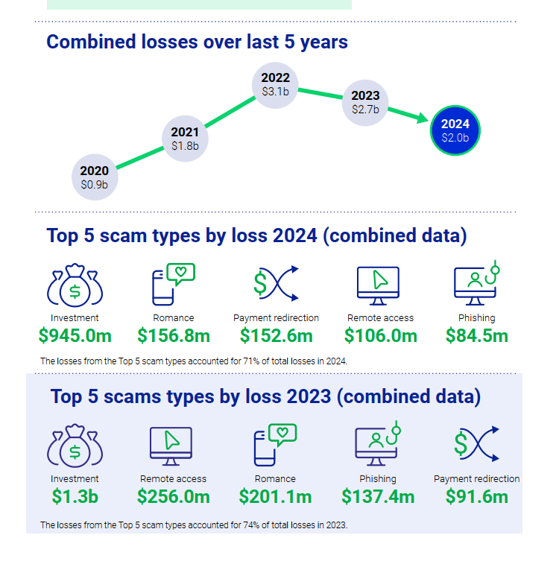
3) Only 1.5% of people reporting phishing scams actually suffered a financial loss
=> Current mitigations are getting better
4) Contact Methods: Email was the most frequently reported contact method for scams generally (90,819 reports), often driven by campaigns impersonating government entities. SMS is another primary channel, with telcos reporting the blocking of over 413.9 million scam SMS in 2024. => Should narrow down the topic to only email, which has been stated and is a good choice.
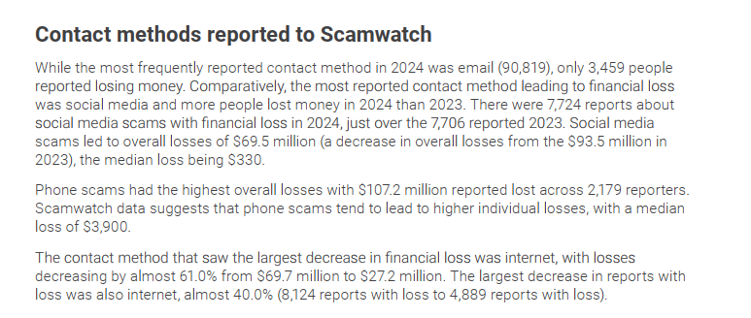
5) Phishing is dangerous:
The problem is worsening due to the professionalisation of cybercrime and new technology.
- Generative AI: Scammers are now using Generative AI to create highly convincing, high-quality spearphishing emails and fake documentation with minimal effort.
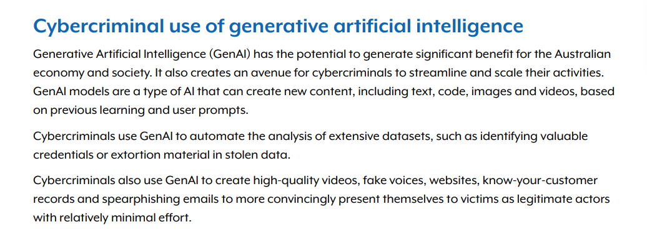
- Credential Theft: Cybercriminals use "info stealer" malware (distributed via phishing) to harvest corporate usernames and passwords, which are then sold on the dark web to allow other actors to compromise networks.
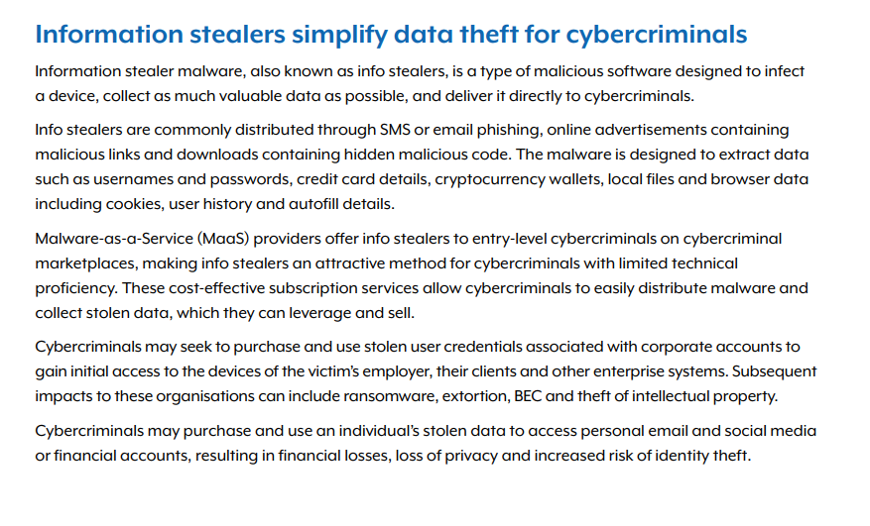

Phishing in the logistic field:
5) More Australians reported a financial loss to shopping scams than any other scam type in 2024, with 10,022 reports with loss totalling $9.8 million
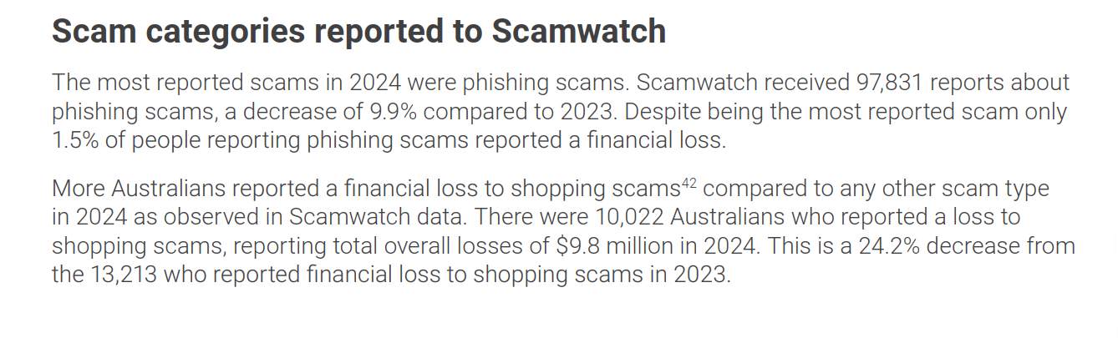
6) Some common patterns of phishing in Aus are:
a. Payment Redirection and Business Email Compromise (BEC)
For the logistics field, which involves high-volume invoicing and supplier relationships, false billing and payment redirection are critical threats.
Impersonation of Suppliers: Scammers target businesses by impersonating legitimate suppliers or service providers to redirect invoice payments to fraudulent accounts.
Financial Impact on Small Business: False billing was the most reported scam type for small businesses (both with and without loss) in 2024. Small businesses reported losing $4.0 million to these scams during the year.
Methodology: These "business email compromise" scams often involve phishing to gain access to email accounts or using spoofed headers to make a fraudulent request for payment look authentic.
b. Impersonation of Brands and "Spoofing"
A major pattern in Australian phishing involves brand impersonation, which frequently includes the misuse of delivery and freight identities.
Alphanumeric Spoofing: Scammers use "alpha tags" (the name displayed as the sender of an SMS) to impersonate trusted brands.
Protective Measures: To combat this, the Australian Communications and Media Authority (ACMA) is implementing a mandatory SMS Sender ID Register to protect the message headers of brands and government agencies from being used in impersonation scams.
Email Spoofing: Phishing campaigns utilize "spoofed" email addresses that appear to come from legitimate organizations, complete with official branding, to trick victims into paying fraudulent fees.
c. Shopping and "Parcel" Adjacent Scams
Phishing in Australia is heavily linked to the online shopping ecosystem, where logistics plays a central role.
High Frequency of Loss: More Australians reported a financial loss to shopping scams (which include online shopping and classifieds) than any other scam type in 2024.
Volume of Reports: Scamwatch received 10,022 reports with loss for shopping scams, totaling $9.8 million. These scams often involve fraudulent websites or communications that mimic the purchase and delivery process
Why phishing related to logistic is significant
7) High Frequency of Attacks on Critical Infrastructure
The logistics sector is classified as Critical Infrastructure (CI), and it is disproportionately targeted compared to other industries.
- Second Most Targeted CI Sector: "Transport, postal and warehousing" accounts for 26% of all critical infrastructure incidents reported to the Australian Signals Directorate (ASD), making it the second most targeted division after financial services.
- Phishing as a Top Threat: Phishing is one of the top three activity types (20%) leading to critical infrastructure-related incidents.
- Sector-Wide Impact: This sector represents 5% of all cyber security incidents reported to the ASD across all Australian industries.
8) Strategic Targeting by State-Sponsored Actors
Disruption of Aid: These actors target the coordination, transport, and delivery of aid to monitor shipments and potentially pre-position themselves for disruptive or destructive cyber effects in the event of conflict.
Espionage: State-sponsored actors use spearphishing to gain access to sensitive proprietary information and research held by Australian businesses.
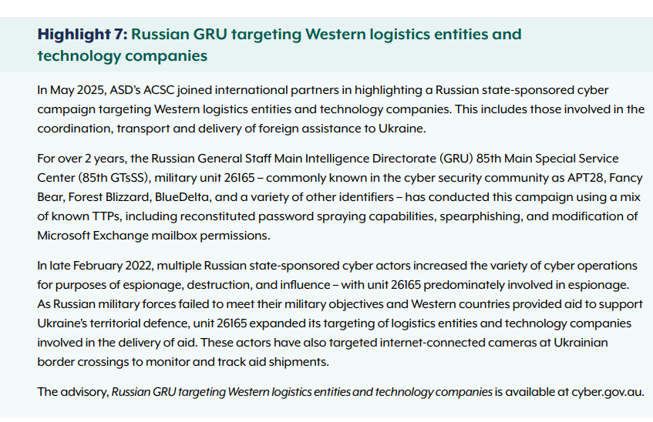
9) Severe Financial and Operational Risks
Phishing is often the "initial access" point for more damaging attacks like ransomware and Business Email Compromise (BEC).
- Skyrocketing Business Costs: The average self-reported cost of cybercrime for large businesses increased by 219% in the 2024-25 period, reaching $202,700 per report.
- BEC Fraud: Business email compromise—often initiated via phishing—is one of the top three cybercrime threats for Australian businesses.
- Ransomware Impact: 34% of major (Category 3) incidents involve ransomware, which can cripple a logistics provider’s ability to function, leading to massive operational losses.

